**Algorithms and Data Structures – 2**

**Module – 2 Activity 11 & 12**

1. BreadthFirstPaths is an implementation of the Paths API that finds shortest paths for an undirected Graph G for all vertices, which runs in O(E + V) time.

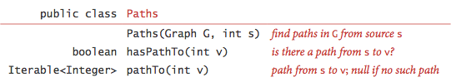

Input:

First Line indicates the number of the Vertices (V).

Second Line indicates the number of the Edges (E).

Third Line indicates the source vertex (s).

Next E lines contains 2 integers which are separated by space.

Output:

Print the distance from source vertex to all the vertices with the count of the edges in brackets given below, followed by the path to the source from vertex.

Example: 0 to 3 (2): 3-2-0

Sample Test Case:

Input:

6

8

0

0 5

2 4

2 3

1 2

0 1

3 4

3 5

0 2

Output:

0 to 0 (0): 0

0 to 1 (1): 1-0

0 to 2 (1): 2-0

0 to 3 (2): 3-2-0

0 to 4 (2): 4-2-0

0 to 5 (1): 5-0